Steps for Converting from Word to HTML
One Suggested Method

- Open the file in Microsoft Word then add accessibility features.
  - Go to Instructional Services Website: http://ww2.nscc.edu/lyle_l. Click on Accessibility and click on the first link on the page to open the file: “File for March 4, 2015.”
  - Add accessibility features. See the handout titled “Syllabus Untagged.”
  - After adding accessibility features, copy the text.
- Use the HTML-Cleaner to remove Word code.
  - Go to Instructional Services Webside: http://ww2.nscc.edu/lyle_l and click on the link titled “HTML-Cleaner.” Be patient, it takes a while to load.
  - Paste the text that you copied from Word into the left window (the source window).
  - Click the Clean HTML button at the lower right side immediately below the HTML window.
Select and copy all of the text in the Source window: Ctrl + A to select all; Ctrl + V to copy.
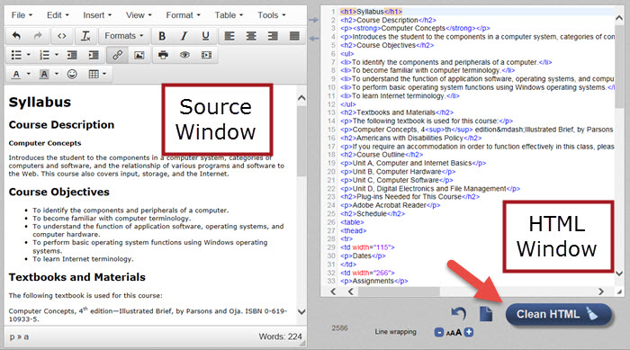
- Go to Desire2Learn to paste the text.
  - Logon to D2L. Go into any of your old courses.
  - Click on Content. If needed, create a module; otherwise, click on a module title.
  - Click the New button and choose Create a File.
  - Click on “Enter a title” and type a name.
  - Click on “Select a Document Template” and click on “Browse for a Template.” Choose “Shared Files” at the left then click on the “Styles” folder at the right. Choose the “D2LBasic” folder. Click the radio button to the left of the file named “D2LBasicTemplateEmbeddedStylesForSyllabus.html.” (More on understanding this later.)
  - Click on Add. You will see a blank screen.
  - Click inside the editing window and paste the text you copied from the HTML-Cleaner.
  - Click on Publish.

Optional
If you wish to remove extra spacing from the table, follow these steps:
- From the D2L editing window, select and copy the table.
- Go to the HTML-Cleaner and paste it to the source window.
- Below the HTML window, enter <p> in the “Find” textbox. Click the plus button to add another box and enter </p> in the “Find” box. Leave the “Replace with” boxes blank.
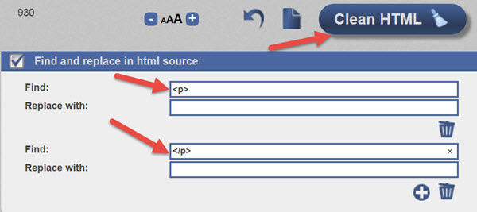
- Click the “Clean HTML.”
- Select the table from the Source window and copy the text. Go to D2L and paste the table at the desired location in the HTML editor.
- Publish.

